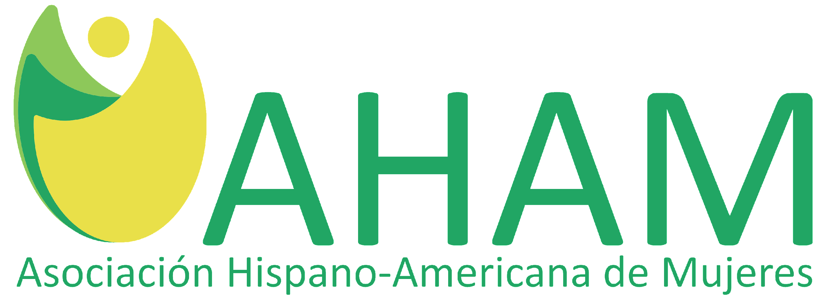

P. O. Box 17674
Greenville, SC 29606
AHAMSC.org
scholarships@ahamsc.org
864-402-4207

This application may be photocopied and distributed. Please print clearly or type.
All applications must be postmarked no later than March 15 2023. You may also complete this application at AHAMSC.org

AHAM COLLEGE SCHOLARSHIP AWARDS PROGRAM FOR 2023
Scholarship Awards Competition for Students of Hispanic Descent
Class of 2023 for the Upstate South Carolina

The Asociación Hispano-Americana de Mujeres (AHAM) welcomes applications from Upstate South Carolina high school seniors of Hispanic origin or descent for its 2023 College Scholarship Awards Program. AHAM is a non-profit organization dedicated to promoting higher education among high school students of Hispanic descent in Upstate South Carolina through educational scholarships. This is our 25th consecutive year granting college scholarships and we are pleased to announce our 2023 awards to eligible Hispanic high school seniors in the following counties in the Upstate SC: Abbeville, Anderson, Cherokee, Greenwood, Greenville, Laurens, Oconee, Pickens, Spartanburg, and Union.

Candidates must be of Hispanic origin or descent (only from Spanish speaking countries, first or second generation), have legal presence in the USA, be in a public or private high school class of 2023, and have a GPA of 3.5 or higher. All applicants must be accepted as a full time student at an accredited university, technical college or vocational school in the United States or USA territories for the fall 2023 semester. AHAM will make the scholarship applications available to the guidance counselors by January 22, 2023. Please direct any questions regarding the application process to your high school Senior Guidance Counselor or send an email to scholarships@ahamsc.org or phone 864-402-4207

REQUIREMENTS- DOCUMENTS

Applicants must enclose the following documentation.
Failure to submit a document will disqualify the applicant.

- A completed and signed application form including address, e-mail, primary and secondary phone numbers (including area code). Applications that are incomplete and/or not signed will not be accepted.
- An official high school transcript.
- Copy of household federal income tax return (1040EZ) for the year 2021 and 2022. Candidate’s families must make $60,000 or less in household income based on their 2020 and 2021 tax return.
- Letter of acceptance to an accredited university, technical college, or vocational school in the USA or US territories for the fall 2023 semester.
- Completed AHAM form listing extracurricular and volunteer activities.
- Copy of document showing legal presence in the USA. (DACA certification, U.S. passport, green card, residency card, social security card, or driver’s license, H4 visa, etc.)
- Letter of Recommendation from the counselor of your school showing financial hardship and academic achievements.
- A TYPED essay (minimum 450 words per topic) describing your goals for college and what career you hope to achieve. Include how your Spanish heritage has influenced your life. Essay must be at least 450 words, include clear and descriptive language, and should have a strong flow/connection.
If you have any questions about the requirements please contact scholarships@ahamsc.org

APPLICATION PROCESS

If you choose to complete this application on paper and mail it, the completed packet must be postmarked by Saturday, March 15, 2023. AHAM makes no exceptions to this rule.

Mail application packet to:
AHAM
Attn: Scholarship Committee
P.O. Box 17674
Greenville, SC 29606

If you choose to apply online (ahamsc.org), you have until Sunday, March 15 at 11:59PM.

SELECTION PROCESS

Scholarship award winners will be evaluated and selected based on four categories: financial need, academic performance, quality of the essay, and interview. Finalists will be interviewed about their ideals, Hispanic heritage, community service, career goals, etc. on a yet-to-be determined date towards the end of April. The place and time for the interviews will be announced and interviews will be held for those who qualify.

The Scholarship Awards Ceremony will be held on May 2023 date and time will be announced directly to the winners and will be open to the public. The local media will be notified. No later than June 30, 2023, AHAM will mail the scholarship funds directly to the financial aid office of the college that the student will attend in the fall of 2023 to use towards tuition and books only.
+++++
If you have any questions, please do not hesitate to send an email to scholarships@ahamsc.org or call
864-402-4207

Thank you and best wishes,

Janeth Garcia Mayiber Quintana/Maria Gomez
President AHAM 2023 Chair, AHAM Scholarship Committee
president@ahamsc.org scholarships@ahamsc.org

2023 SCHOLARSHIP APPLICATION

This application may be photocopied and distributed.
All applications must be postmarked no later than March 15, 2023. You may also complete this application at AHAMSC.org.

APPLICATION MUST BE CLEAR AND LEGIBLE

PERSONAL INFORMATION
Complete Name (First Name, Last Name)_______________________________________________________
Date of birth______________________________________________________________________________
Nationality_______________________________________________________________________________
Mailing Address (Street, City, State, Zip Code)___________________________________________________
Mobile number (this should be the best number we can reach you at)_______________________________
Alternate cellphone number_________________________________________________________________
Personal email address_____________________________________________________________________
Do you have a criminal record or have you ever been convicted of drug possession?___________________
How did you find out about our scholarships program?___________________________________________
Guardian(s) Full Name(s) Guardian's Phone Number(s)_________________________________________
Do your parents file taxes together?__________________________________________________________
Who supports you financially?_______________________________________________________________
Do you qualify for FAFSA? ___________________________________________________
Who is the household head in your family?_____________________________________________________
Name your family members in your household__________________________________________________
Which is the highest Parents' education level?__________________________________________________

ACADEMIC INFORMATION
Name and address of the high school from which you will graduate/ school district___________________________________________________________________________________
GPA - SAT ________________________________________________________________________________
What country (or countries) of Hispanic Heritage do you represent?________________________________
Name and address of the university you plan to attend this upcoming fall semester____________________
What will be your major area of study_________________________________________________________
List any extra hours of volunteering different from the ones you mentioned in the AHAM Volunteer form (if applicable)_______________________________________________________________________________
Do you and any member of your family agree to volunteer during the year in all the activities that AHAM will have as a way to support our organization?_________________________________________________
Have you been awarded other scholarship(s)?__________________________________________________ If your financial situation changes after submitting your application, you are required to notify us.

DOCUMENTATION
A TYPED essay (minimum 450 words per topic) describing your goals for college and what career you hope to achieve. Include how your Spanish heritage has influenced your life. Essay must be at least 450 words, include clear and descriptive language, and should have a strong flow/connection.

If I am a finalist and/or a scholarship recipient, I understand that my name and picture will be used for publicity purposes without any compensation due to me or my family by AHAM or its members.________

By mailing this application, I agree to volunteer a minimum of ten (10) hours with AHAM during any of its 2023 fundraising events. I will contact fundraising@ahamsc.org or call (864) 402-4207 for more information.

By signing below, my family and/or I waive and/or hold AHAM, its members, and/or sponsors harmless of any incident and/or accident, which may happen during my time as AHAM volunteer
Attach a copy of the documents requested in section 1. and also email them to: scholarships@ahamsc.org

_____________________________________ ________________________________
Applicant Printed Name Applicant Signature

All completed applications and required documentation must be postmarked no later than
Saturday, March 15 2023. Please note that only a few selected post offices are open on Saturdays.

All completed application packets must be postmarked by March 15, 2023. No exceptions.
IF THE DOCUMENTATION IS NOT COMPLETED IT WILL DISQUALIFY

EXTRACURRICULAR/VOLUNTEER ACTIVITIES
Please list clearly extracurricular and volunteer activities in which you have been involved at school such as clubs, sports, student council, etc.; the community and church groups such as volunteer community projects, leadership programs, and other activities. AHAM reserves the right to confirm that you have completed the volunteer activities listed in this form. False statements will automatically disqualify applicants from any further consideration in the scholarship competition process.

Organization | Organization Contact Phone/Email | Activity | Dates |  | Total Hours
 |  |  | From | To
WORK EXPERIENCE:

Use additional pages if needed.

By signing and submitting this form, I am confirming that all statements are true and that I have completed the volunteer activities described herein. I authorize AHAM to confirm my voluntary involvement in these organizations at their discretion.

Signature |  | Date
Printed Name
CHECKLIST: Optional

- A completed TYPED or clearly PRINTED and signed application form including address, telephone numbers, and e-mail address. Applications that are incomplete and/or not signed will not be accepted.

- A completed TYPED or clearly PRINTED volunteer form.

- An official school transcript.

- Copy of household federal income tax return (1040ez) for the year 2021. Family income not greater than $60,000.

- A TYPED essay (minimum 450 words per topic) describing your goals for college and what career you hope to achieve. Include how your Spanish heritage has influenced your life. Essay must be at least 450 words, include clear and descriptive language, and should have a strong flow/connection.

- Copy of letter of acceptance to university, technical college, or vocational school.

- Copy of document showing legal presence in the USA.

